DAT 515 uCertify Lab Activity Worksheet

Module Labs
Module 6

Lab Screenshots
18.3.1
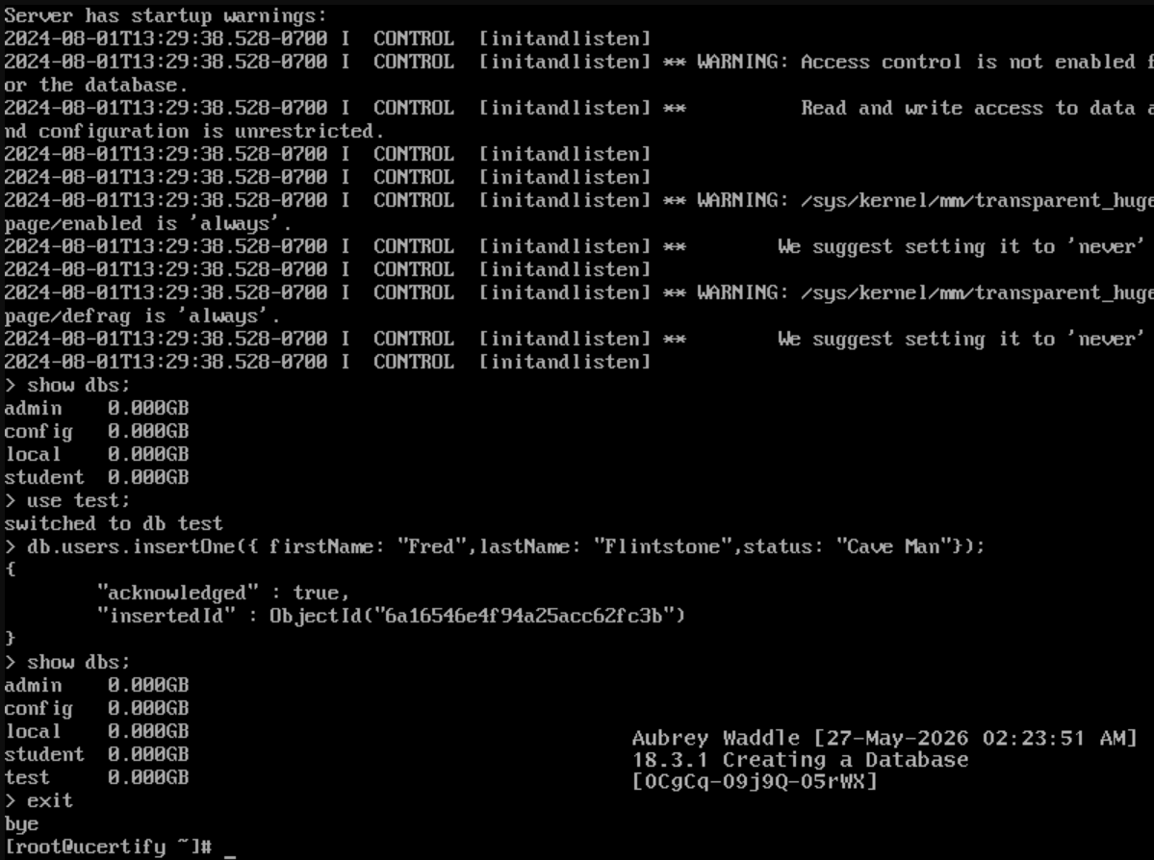
18.3.2
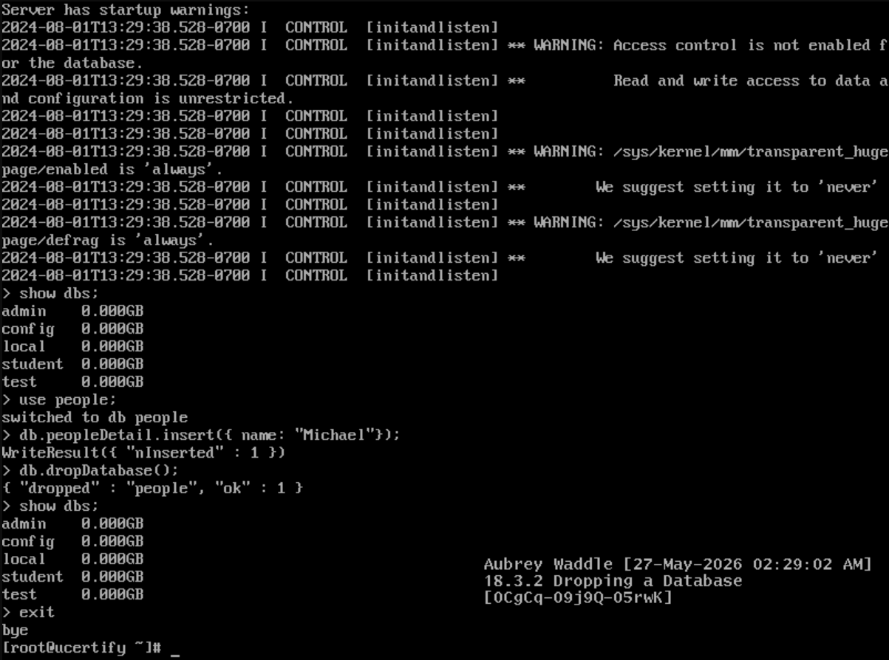
18.3.3
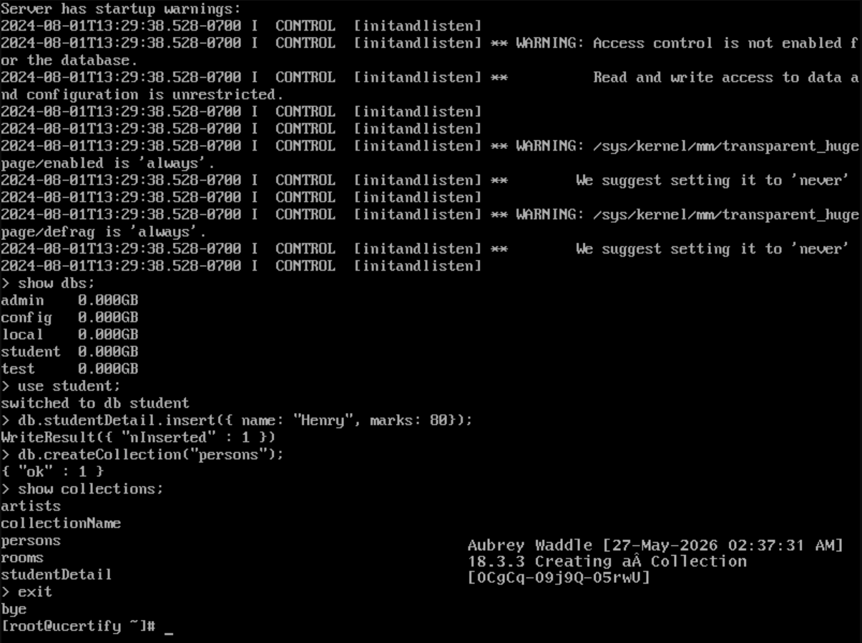
18.3.4
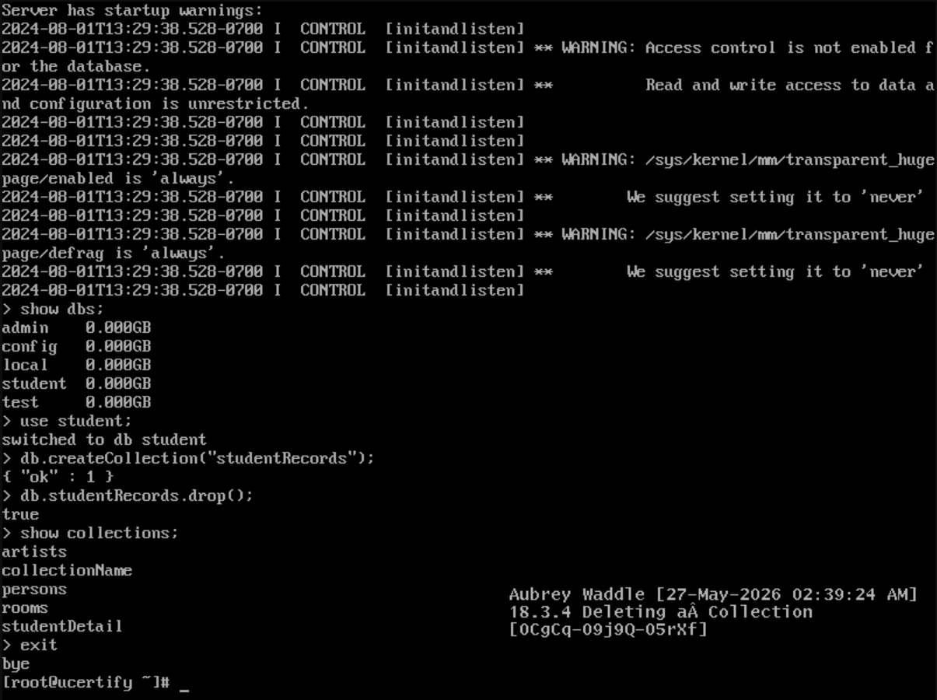
18.4.1
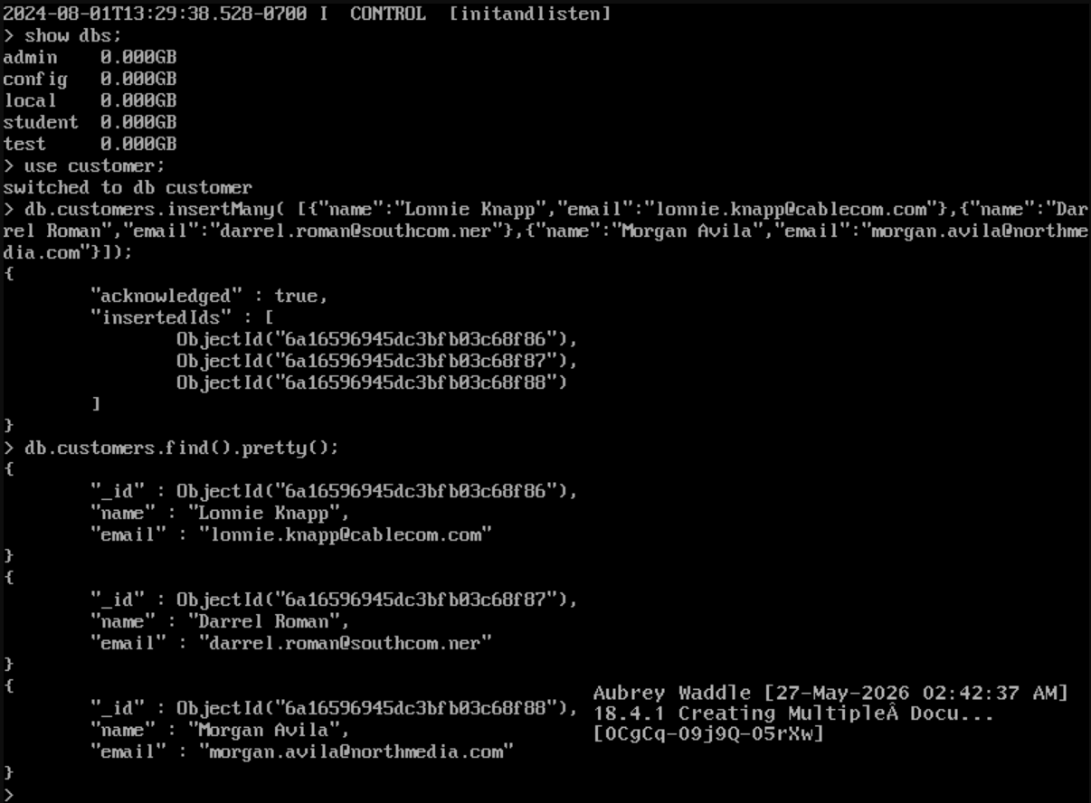
18.4.2
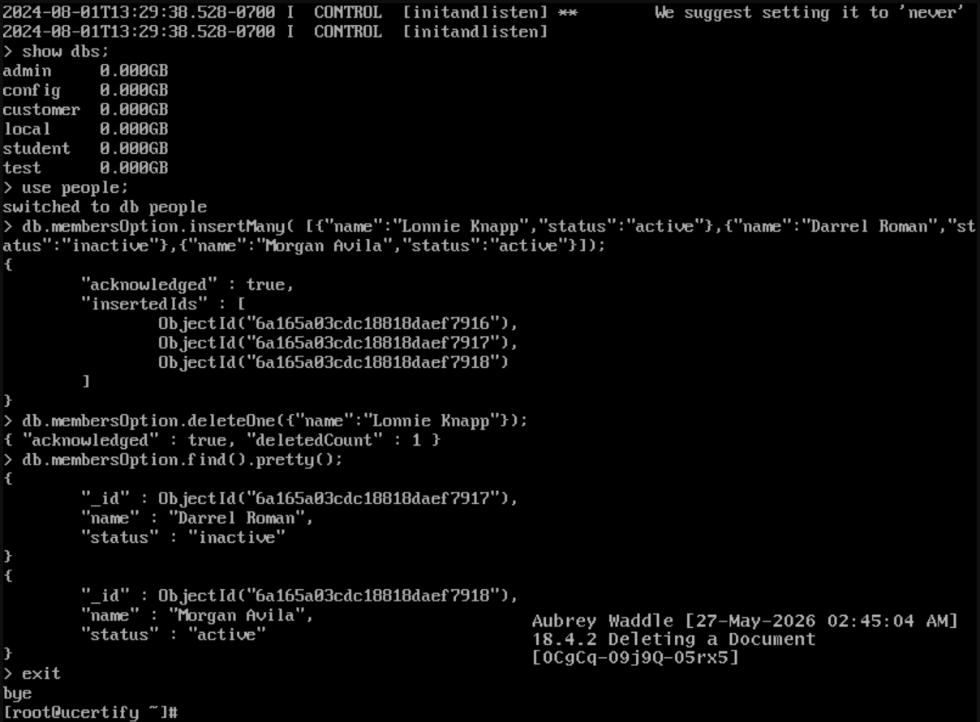
20.2.1
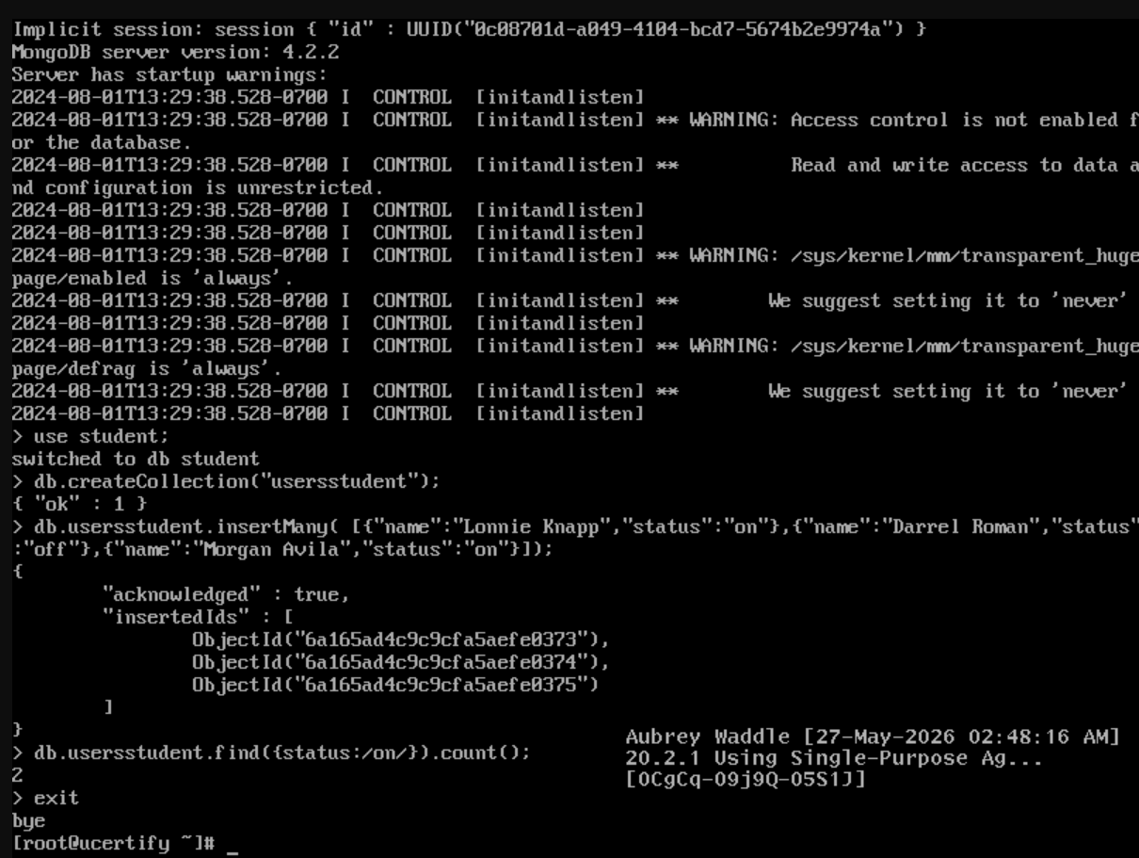
20.3.1
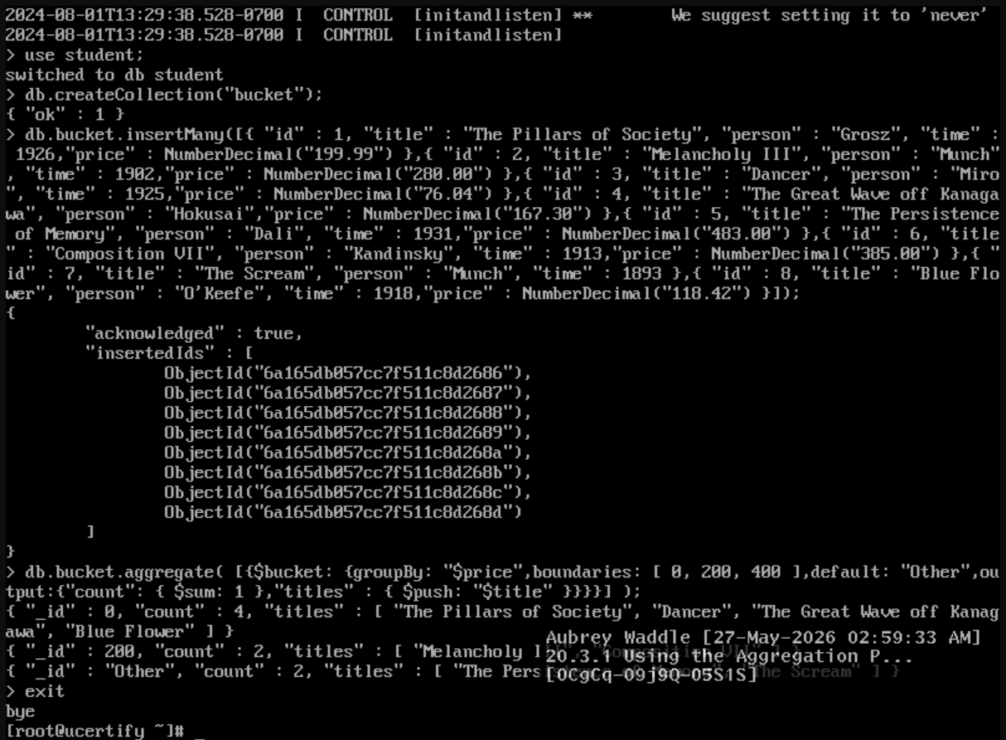
20.3.2
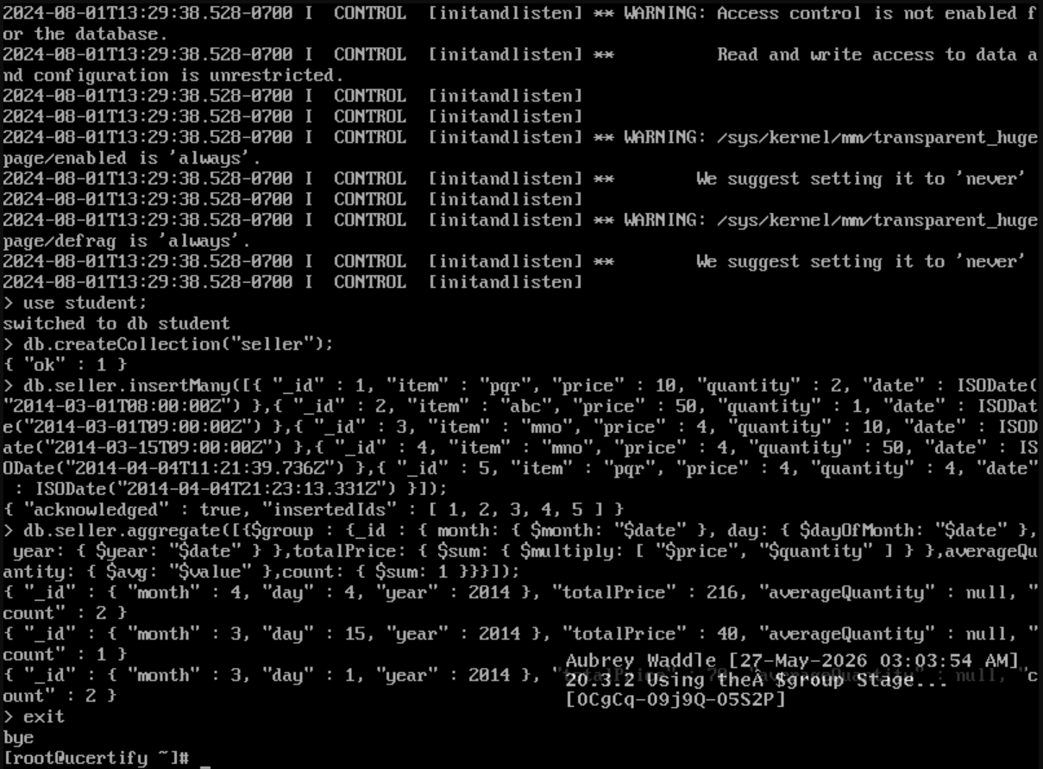
20.3.3
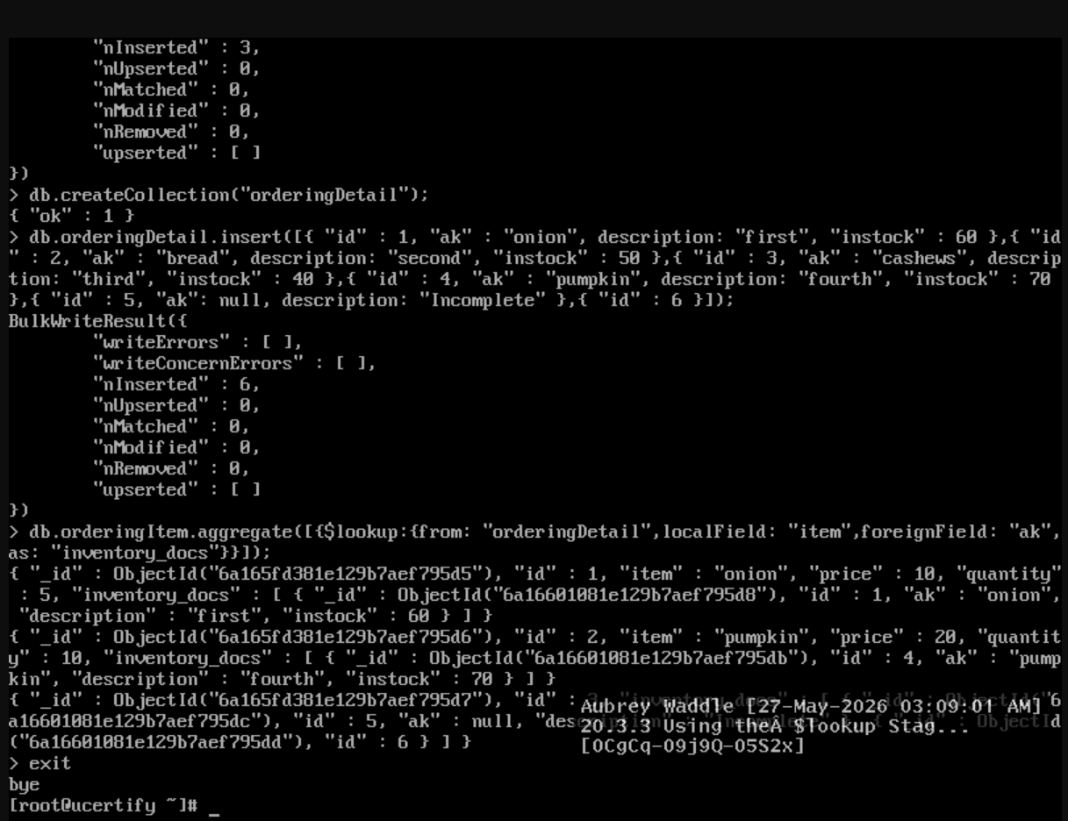

Lab Reflection

18.3.1
In this lab I established and looked at databases in the mongo shell. I worked on creating a new database and collection automatically with use command to switch between databases and insert a document. MongoDB was more dynamic in handling the structure yet this was the same method to create schemas in MySQL.
18.3.2
The aim of this experiment was to destroy a database using the dropDatabase() function of MongoDB. I created a sample database and collection then removed the database and confirmed using show dbs. Relational databases could not provide the facility to add and remove database structures quickly with shell commands but MongoDB does.

18.3.3
In this lab, I manually created a collection with createCollection () command and saw it with show collections. I also added some example records to the database in order to test the structure of the collection. MongoDB collections don’t need pre-defined schemas, but the process was more like making tables in SQL.
18.3.4
The collection was created and then dropped in this experiment using the drop() command. I then showed the other collections in the database to see if it had been deleted. MongoDB included collection based nomenclature and commands, but the approach was similar to dropping tables in SQL.
18.4.1
In this lab I inserted multiple documents into a MongoDB Collection using insertMany() function. Next I used find() to display the records.The pretty() command can be used to see the inserted data. This process was similar to inserting several rows into SQL. MongoDB saved the data as flexible JSON-like objects.
18.4.2
In this lab we removed a specific document from a collection with the deleteOne() command. I then validated the results by looking at the rest of the documents in the collection. In MongoDB, you specify the data you want to delete using document filters, rather than SQL delete statements.
20.2.1
In this lab I use the ability of MongoDB to aggregate and count the number of records in a collection that meet some requirements. I made a few documents with different status values and then aggregated the data with a filter using the count() function. We used mongoDB’s query syntax but it was similar to the SQL aggregation method of COUNT().
20.3.1
In this lab we used the $bucket stage of MongoDB’s aggregate pipeline to bucket the records. Then I entered the artwork data and categorized them and counted how many objects were in each category. This allowed more complex manipulation and classification of data than simple queries.
20.3.2
In this lab I used the $group stage and accumulator operators ($sum, $multiply etc.) to summarize the sales data. Totals and counts were aggregated, and summed by date values for each data set. It was like doing SQL GROUP BY expressions with aggregate functions.
20.3.3
In this lab, the purpose is to do the linking of comparable collections using the MongoDB $lookup stage. I created two collections to show inventory detail with ordering information and linked related items. This method was much like merging tables in relational systems like MySQL.

I heavily used the mongo shell to build databases, collections, documents and queries for aggregation during these labs. MongoDB's document-based structure is more flexible than SQL's strict relational tables yet many of the processes were similar to SQL concepts of joining, grouping, filtering and aggregation.

